DBSentryFileSync Design Document
Date : 1/29/96  Document Author: Jeetendra Prasad | DBSentryFileSync Team:  Name (Manish Gupta)  Name (Jeetendra Prasad)

Project Description of Target System
DBSentryFileSync is a file synchronization application. It allows two replicas of a collection of files and directories to be stored on different hosts, modified separately, and then brought up to date by propagating the changes in each replica to the other.
Currently the supported file systems are cmsdk and UNIX. It will be implemented using client-server architecture. And they will communicate using JXTA. The server will decide the file system to which client can connect. This way it gives one point control to the administrator to switch between different file systems. Since it is implemented using JXTA, the location of server need not be fixed and client need not know, where server is located. It provides secured communication between the client and the server.
Features of DBSentryFileSync:
- Since developed in java, it can be run on any operating system.
- It uses JXTA as transport protocol.
- Transfer of data in a secured way. Using secured socket.
- It user advanced algorithm to compare document for their difference in content.
- Will make the file system transparent to the client.
- it uses plug in to serve different file system. So adding new file system will be as simple as copying the jar file in the class path and modifying configuration file.
- The server will run as a service in the background
- Easy to use client interface
- It is resilient to failure. It is careful to leave the replicas and its own private structures in a sensible state at all times, even in case of abnormal termination or communication failures.

Features of the client:
- Developed using java
- Secured login using user id and password
- It will display the file system of client and server
- User can perform all the navigation operation like forward, backward, up, go to a given folder etc. on both, the client and the server
- Select files and folder to compare based on different option like date and content. And then they can be synchronized.
- Uses advanced algorithm to compare file for content change. So that you do not compare byte by byte.
- Easy to use interface

Features of the server
- Developed using java
- It will run as a service in the background
- Will make the file system transparent to the client
- It uses simple configuration file to define various parameter
- It uses plug in to serve different file system. So adding new file system will be as simple as copying the jar file in the class path and modifying configuration file

High-level architecture
This application has two major components: DBSentryFileSync Client and DBSentryFileSync Server.

Client
The client starts by initializing JXTA, as it is necessary for starting JXTA communication with the server. Then it provides user with a screen to login to the server. On successful authentication it displays the list of files and folder in the user’s home folder on both the system i.e. the client and the server. User can navigate in the directory structure of both the file system depending on his rights. Then he can select the files and the folder to synchronize. He can select the option based on which he wants to compare and synchronize the file. If the system cannot decide which file will be transferred to which side then he is provided with option to decide what system should do. For example, suppose he decides to compare the files for difference in content. And he finds a list of files whose content are not same. Then he can decide which file to transfer on which side.

Server
The server also starts by first initializing the JXTA. This is necessary to start JXTA communication. This is one time operation. Then we are provided with the option to select a file system to server. This is also one time operation. Latter it can be changed by modifying the configuration file. The switching of file system will be done using plug in so that addition of new file system is easy. The server can me made to run as a service.

DBSentryFileSync Server

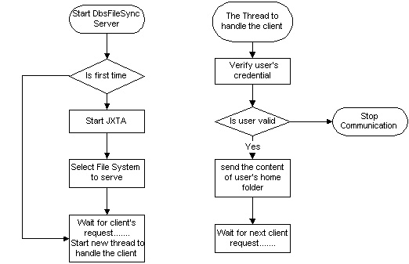

DBSentryFileSync Client

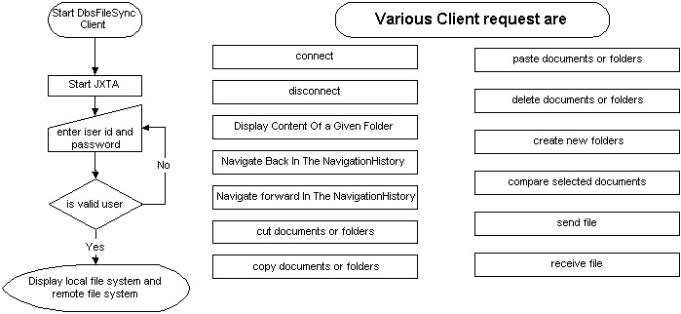

User Interface

I will design the user interface and paste it here

Detail Plug in specification will go here

